**Problem Set 1**

Basic Level

1. Please draw the indifferent curves when both goods are bads (instead of goods).

2. Please prove that any two indifferent curves cannot intersect.

3. Please draw the indifferent curve of utility function . Please indicate whether it is the preference of substitutes or complements.

Intermediate Level

4. We call the utility function is a function with constant elasticity substitution（常替代弹性效用函数，简称CES函数）. Please prove that:

(1) It is the utility function of perfect substitutes when ;

(2) It is the utility function of perfect complements when ;

(3) It is a Cobb-Douglas utility function when .

5. Please draw the indifferent curves of the following utility functions:

(1)

(2)

(3)

6. The utility function is . The price of is 25/unit, while the price of is 15/unit. Finally, the consumer chooses the consume 7 unit of . Please find out the income of the consumer.

7. The utility function is $u=x_{1}+\sqrt{x_{2}+x_{3}}$. The consumer’s income is 100, and the prices of goods $x_{1}$, $x_{2}$ and are 1, 2 and 3. Please work out the optimal choice of consumer.

Difficult Level

8. The town of Greenville has three types of families, each with one child, and each of which earns $20,000 per year (pre-tax). Each family is taxed $4,000 per year to finance the public school system in the town. Families can always send their kids to the public school without paying tuitions. Public schools spend $6,000 for each student. If the family wants more than $6000 education expenditure for their children, they need to go to private school, which is not subsidized at all. The three families differ in their preferences for education. Though families A and B both send their children to the public school, family B places a greater value on education than family A. Family C places the greatest relative value on education and sends their child to private school. **Please graph the budget constraints facing each of the three families, and draw a possible indifference curve that could correspond to the choice each family makes.**

9. Suppose Yunwen’s utility function is given by . Initially, Yunwen has $600 to spend on these commodities, and the prices of and are both $1.

(1) How many units of should she buy to maximize her utility?

*Now the government wants to encourage the consumption of .*

(2) If the government offers the consumption coupon of $100 to each consumer that can be spent as they wish, how many units of will Yunwen buy to maximize her utility?

(3) If for every unit of that Yunwen buys, the government will give her $0.5, how many units of will she buy to maximize her utility?

(4) If the government offers 100 stamps to each consumer, and each stamp can be exchanged for 1 unit of from supermarkets**, how many units of will Yunwen buy to maximize her utility?** One step further, consider there is a black market where the consumers can sell their stamps at the price of $0.8, but they cannot buy stamps. **Then how many units of will Yunwen buy now?**

10. Yunwen works in a machine factory. She can work as many hours per day as she wishes at a wage rate of . Let *C* be the number of dollars she spends on consumption and let *R* be the number of hours of leisure that she chooses. Assume that Yunwen has the utility function . Yunwen earns $8 per hour and has 18 hours per day to devote to labor or leisure, and she also has $16 of nonlabor income per day.

(1) Please write down her budget constraint.

(2) How many consumptions will she choose? How many hours per day will she work?

(3) Suppose that Yunwen’s wage rate rises to $12 per hour. How many hours of leisure per day will she choose?

(4) Now suppose there are no taxes on the first $48 of labor income that Yunwen earns per day, but once the labor income is above $48, she must pay a 50% tax on the excess (her wage rate is still $8 per hour). There is no tax on nonlabor income. How many hours per day will she work?

Basic Level

1. 【中级微观经济学学习指南（西财版）第二章例题】Please draw the indifferent curves when both goods are bads (instead of goods).

Answer:

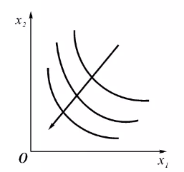

2. 【中级微观经济学学习指南（西财版）第二章例题】 Please prove that any two indifferent curves cannot intersect.

Answer:

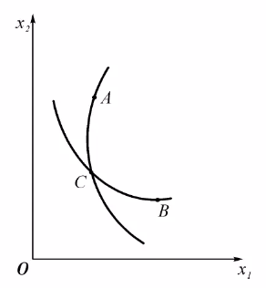

Suppose an indifferent curve with node A and another indifferent curve with node B has an intersect $C$. Then, $x^{A}\sim x^{C}$, $x^{B}\sim x^{C}$. From transitivity, we have $x^{A}\sim x^{B}$. However, it contradicts to the fact that A and B are on different indifferent curves.

3. 【中级微观经济学学习指南（西财版）第二章例题】Please draw the indifferent curve of utility function $U=3\left(x_{1}^{2}+2x_{1}x_{2}+x_{2}^{2}\right)+10$. Please indicate whether it is the preference of substitutes or complements.

Answer:

$$x_{1}+x_{2}=\sqrt{\frac{U-10}{3}}$$

It is the preference of perfect substitutes.

Intermediate Level

4. 【中级微观经济学学习指南（西财版）第二章思考题】 We call the utility function $U={\left(α_{1}x_{1}^{ρ}+α_{2}x_{2}^{ρ}\right)}^{\frac{1}{ρ}}$ is a function with constant elasticity substitution（常替代弹性效用函数，简称CES函数）. Please prove that:

(1) It is the utility function of perfect substitutes when $ρ=1$;

(2) It is the utility function of perfect complements when $ρ=-∞$;

(3) It is a Cobb-Douglas utility function when $ρ=0$.

Answer:

(1) When $ρ=1$， $U=α_{1}x_{1}+α_{2}x_{2}$, which is the utility function of perfect substitutes.

(2) When $ρ=-∞$，

$$U=\left\{\begin{aligned}{\lim_{ρ→-∞}\left(α_{1}x_{1}^{ρ}+α_{2}x_{2}^{ρ}\right)}^{\frac{1}{ρ}}={\lim_{ρ→-∞}{x_{2}\left(α_{1}{\left(\frac{x_{1}}{x_{2}}\right)}^{ρ}+α_{2}\right)}}^{\frac{1}{ρ}}=x_{2} if x_{1}>x_{2} \\ {\lim_{ρ→-∞}\left(α_{1}x_{1}^{ρ}+α_{2}x_{2}^{ρ}\right)}^{\frac{1}{ρ}}={\lim_{ρ→-∞}{x_{1}\left(α_{2}{\left(\frac{x_{2}}{x_{1}}\right)}^{ρ}+α_{1}\right)}}^{\frac{1}{ρ}}=x_{1} if x_{2}>x_{1} \\ x_{1}=x_{2} if x_{1}=x_{2}\end{aligned}\right.$$

Thus, $U=\min{\{x_{1},x_{2}\}}$, which is the utility function of perfect complements.

(3) When $ρ=0$, with L'Hôpital's rule,

$$\ln{U}=\lim_{ρ→0}{\frac{\ln\left(α_{1}x_{1}^{ρ}+α_{2}x_{2}^{ρ}\right)}{ρ}}=\lim_{ρ→0}{\frac{α_{1}x_{1}^{ρ}\ln{x_{1}}+α_{2}x_{2}^{ρ}\ln{x_{2}}}{α_{1}x_{1}^{ρ}+α_{2}x_{2}^{ρ}}}=\frac{α_{1}\ln{x_{1}}+α_{2}\ln{x_{2}}}{α_{1}+α_{2}}⁡$$

Thus,

$$U=x_{1}^{\frac{α_{1}}{α_{1}+α_{2}}}x_{2}^{\frac{α_{2}}{α_{1}+α_{2}}}$$

which is a Cobb-Douglas utility function.

5. 【中级微观经济学学习指南（钟根元、陈志洪版）第四章拓展题】Please draw the indifferent curves of the following utility functions:

(1) $u\left(x,y\right)=x+y+\min{\{x,y\}}$

(2) $u\left(x,y\right)=y+\min\left\{x,y\right\}$

(3) $u\left(x,y\right)=\min{\{4x+y,2x+2y,x+4y\}}$

Answer:

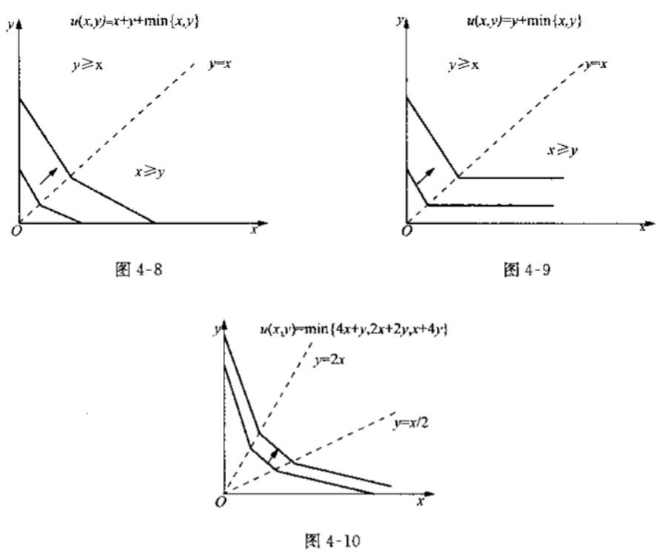

6. 【钟根元《中级微观经济学学习指南》（第四版）第五章 计算题4】The utility function is $u\left(x,y\right)=\min\left\{x,y^{2}\right\}$. The price of $x$ is 25/unit, while the price of $y$ is 15/unit. Finally, the consumer chooses the consume 7 unit of $y$. Please find out the income of the consumer.

Answer:

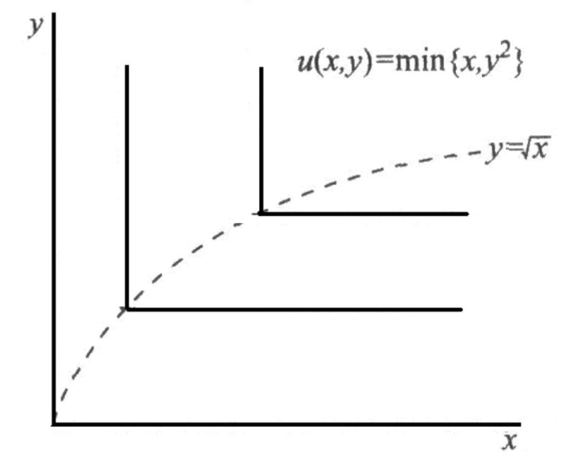

The figure above is the indifferent curves. When $y=7$, $x=49$. The consumer’s income is .

7. 【钟根元《中级微观经济学学习指南》（第四版）第五章 计算题5】The utility function is $u=x_{1}+\sqrt{x_{2}+x_{3}}$. The consumer’s income is 100, and the prices of goods $x_{1}$, $x_{2}$ and $x_{3}$ are 1, 2 and 3. Please work out the optimal choice of consumer.

Answer:

$x_{2}$ and $x_{3}$ are perfect substitutes, so the consumer will only consume $x_{2}$ when $p_{2}<p_{2}$. When utility is maximized, $\frac{2}{\frac{1}{2}x_{3}^{-\frac{1}{2}}}=1$. Thus, $x_{2}=\frac{1}{16}$.

The consumer’s optimal choice is $(99.875,\frac{1}{16},0)$.

Difficult Level

8. 【公共财政学第11章例题】The town of Greenville has three types of families, each with one child, and each of which earns $20,000 per year (pre-tax). Each family is taxed $4,000 per year to finance the public school system in the town. Families can always send their kids to the public school without paying tuitions. Public schools spend $6,000 for each student. If the family wants more than $6000 education expenditure for their children, they need to go to private school, which is not subsidized at all. The three families differ in their preferences for education. Though families A and B both send their children to the public school, family B places a greater value on education than family A. Family C places the greatest relative value on education and sends their child to private school. **Please graph the budget constraints facing each of the three families, and draw a possible indifference curve that could correspond to the choice each family makes.**

Answer:

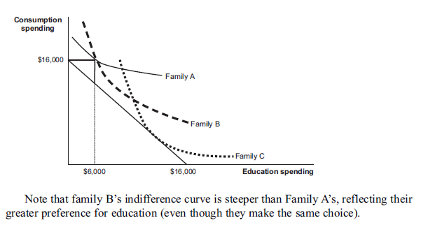

9. 【何韵文学姐供题】Suppose Yunwen’s utility function is given by . Initially, Yunwen has $600 to spend on these commodities, and the prices of and are both $1.

(1) How many units of should she buy to maximize her utility?

*Now the government wants to encourage the consumption of .*

(2) If the government offers the consumption coupon of $100 to each consumer that can be spent as they wish, how many units of will Yunwen buy to maximize her utility?

(3) If for every unit of that Yunwen buys, the government will give her $0.5, how many units of will she buy to maximize her utility?

(4) If the government offers 100 stamps to each consumer, and each stamp can be exchanged for 1 unit of from supermarkets**, how many units of will Yunwen buy to maximize her utility?** One step further, consider there is a black market where the consumers can sell their stamps at the price of $0.8, but they cannot buy stamps. **Then how many units of $x$ will Yunwen buy now?**

Answer:

(1) $x=\frac{0.1*600}{1}=60$;

(2) $x=\frac{0.1*700}{1}=70$;

(3) $x=\frac{0.1*600}{0.5}=120$;

(4)

* Without a black market, $x=$ 100;

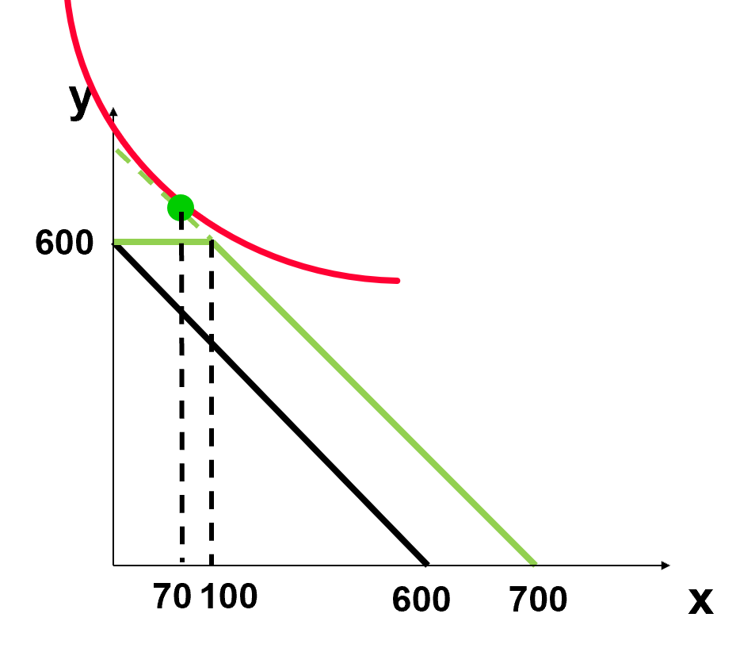

max $x^{0.1}y^{0.9}$ s.t. $\left\{\begin{aligned}y=600, x≤100 \\ x+y=700, x>100\end{aligned}\right.$

We can prove that $U=x^{0.1}{(700-x)}^{0.9}$ is a decreasing function when $x>100.$

* With a black market, $x=$ 85

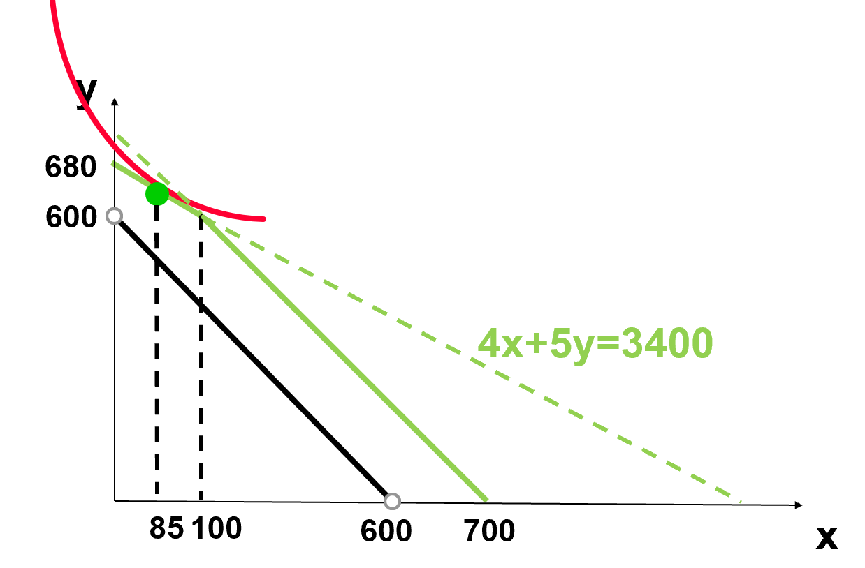

max $x^{0.1}y^{0.9}$ s.t. $\left\{\begin{aligned}4x+5y=3400, x≤100 \\ x+y=700, x>100\end{aligned}\right.$

10.【何韵文学姐供题】Yunwen works in a machine factory. She can work as many hours per day as she wishes at a wage rate of $ω$. Let *C* be the number of dollars she spends on consumption and let *R* be the number of hours of leisure that she chooses. Assume that Yunwen has the utility function . Yunwen earns $8 per hour and has 18 hours per day to devote to labor or leisure, and she also has $16 of nonlabor income per day.

(1) Please write down her budget constraint.

(2) How many consumptions will she choose? How many hours per day will she work?

(3) Suppose that Yunwen’s wage rate rises to $12 per hour. How many hours of leisure per day will she choose?

(4) Now suppose there are no taxes on the first $48 of labor income that Yunwen earns per day, but once the labor income is above $48, she must pay a 50% tax on the excess (her wage rate is still $8 per hour). There is no tax on nonlabor income. How many hours per day will she work?

Answer:

(1) $C+8R=8*18+16=160$

(2) $C=\frac{1*160}{2}=80, R=\frac{1*160}{2*8}=10$, work 8 hours;

(3)

budget constraint: $C+12R=12*18+16=232$

$$R'''=\frac{1*232}{2*12}=\frac{29}{3}$$

(4) new budget constraint:

$$\left\{\begin{aligned}C=6+8（18-R）, R≥12 \\ C=16+48+4\left(12-R\right), R<12\end{aligned}\right.$$

R=12, work 6 hours.